**SOUTHERN RIVER COLLEGE**

**Human Biological Science**

**Unit 3 & 4**

**TASK 10**

**Harry Perkins Excursion Validation -**

**Techniques in Biotechnology**

**Time: 60 mins**

**Weighting: 5%**

**Do not turn page until instructed to do so**



**(55 Marks)**

This section has ten (10) questions. Answer all questions. Write your answers in the spaces provided in this Question/Answer Booklet. Use a blue or black pen for this section.

**Question 1**

What is the function of each of the following in gel electrophoresis of DNA?

a) Agarose gel: (2 marks)

________________________________________________________________________

________________________________________________________________________

b) Electric current: (1 mark)

_________________________________________________________________________

_________________________________________________________________________

c) "Wells" in the gel: (1 mark)

________________________________________________________________________

_________________________________________________________________________

**Question 2**

a) Toward which pole (positive or negative) does DNA migrate when electric current is run through the gel? (1 mark)

_________________________________________________________________________

b) Why do the DNA molecules move toward this pole? (1 mark)

_________________________________________________________________________

**Question 3**

What would happen to the DNA fragments if you forgot to turn the current off? (1 mark)

_________________________________________________________________________

**Question 4**

Describe how the different sized DNA fragments are separated by the gel matrix. (2 marks)

_________________________________________________________________________

__________________________________________________________________________________________________________________________________________________

**Question 5**

Examine the diagram of an agarose gel below and answer the following questions.

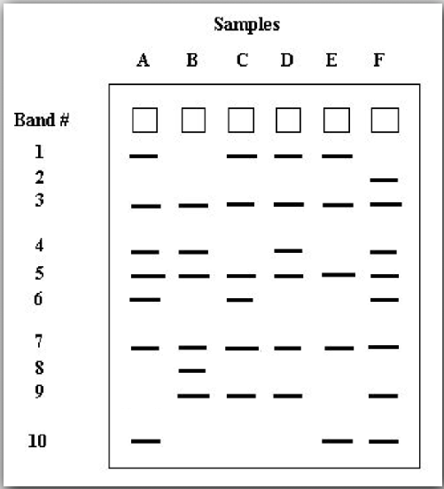

a) What do the bands in the drawing of the agarose gel represent? (1 mark)

_________________________________________________________________________

_________________________________________________________________________

b) Which band(s) travelled slowest? (1 mark)

_________________________________________________________________________

c) Which band(s) travelled fastest? (1 mark)

_________________________________________________________________________

d) On the above drawing, label the positive and negative ends of the gel. (1 mark)

e) How many bands are shared in common by all of the individuals? List these common bands. (2 marks)

_________________________________________________________________________

f) Are there any bands that are unique to only one individual? If so, which one/s? (2 marks)

_________________________________________________________________________

_________________________________________________________________________

**Question 6**

Orangutans are an endangered species of ape that live in Southeast Asia. Their numbers have dwindled due to habitat loss and poaching, but there are currently efforts to save the orangutans.

DNA fingerprinting has been used by Dr. Benoit Goossens at Cardiff University to better understand mating and genetic variation in orangutans.

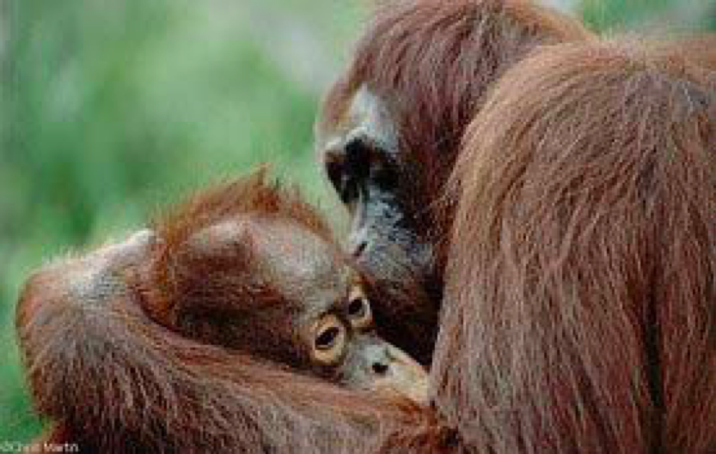

Use DNA fingerprinting (see below) to determine which male orangutan is the father of a baby orangutan. You will have DNA from the baby orangutan and several possible father orangutans. It is your job to determine which is the father .

Mother baby Male 1 Male 2



a) Who is the father of the baby orangutan? (1 mark)

_________________________________________________________________________

b) Explain how you reached this conclusion (2 marks)

_________________________________________________________________________

_________________________________________________________________________

_________________________________________________________________________

**Question 7**

a)Explain what is meant by DNA profiling/fingerprinting and how it is different to DNA sequencing? (2 marks)

_________________________________________________________________________

_________________________________________________________________________

_________________________________________________________________________

_________________________________________________________________________

b) List 2 fields that would use PCR in their work on a regular basis (other than medical).   
 (2 marks)

_________________________________________________________________________

_________________________________________________________________________

**Question 8**

a) What does PCR stand for, and what is its purpose? What role does electrophoresis play in this process? (3 marks)

_________________________________________________________________________

_________________________________________________________________________

_________________________________________________________________________

_________________________________________________________________________

b) What is a primer? (3 marks)

_________________________________________________________________________

_________________________________________________________________________

_________________________________________________________________________

_________________________________________________________________________

c) What is Taq polymerase and what does it do? (2 marks)

_________________________________________________________________________

_________________________________________________________________________

d) List the three stages in PCR and describe what occurs at each stage. (6 marks)

_________________________________________________________________________

_________________________________________________________________________

_________________________________________________________________________

_________________________________________________________________________

_________________________________________________________________________

_________________________________________________________________________

_________________________________________________________________________

_________________________________________________________________________

e) Why did you place a water sample in the thermocycler? (2 marks)

_________________________________________________________________________

_________________________________________________________________________

_________________________________________________________________________

f) Name any four of the reagents in the Master Mix (2 marks)

_________________________________________________________________________

_________________________________________________________________________

_________________________________________________________________________

g) What is a DNA ladder, and why is it used? (2 marks)

_________________________________________________________________________

_________________________________________________________________________

**Question 9**

a) What is BRAF and what does it do? (2 marks)

_________________________________________________________________________

_________________________________________________________________________

_________________________________________________________________________

b) What effect does the mutated BRAF gene have in melanoma, and what is the significance of this gene in melanoma? (2 marks)

_________________________________________________________________________

_________________________________________________________________________

_________________________________________________________________________

**Question 10**

Experiments are being conducted where mice are injected with altered genes. This could enable individuals with the mutated BRAF gene, to undergo gene therapy, replacing the faulty gene with a healthy one.

a) Identify the process used to create the altered gene which is being injected into the mice.

_______________________________________________________________ (1 mark)

b) Name and describe the role of the two enzymes involved in the process you identified in part a). (6 marks)

i. _________________________________

_________________________________________________________________________________________________________________________________________________________________________________________________________

ii. _________________________________  
_________________________________________________________________________________________________________________________________________________________________________________________________________

END OF TEST